Research in the Classroom: Do I Need REB Approval?
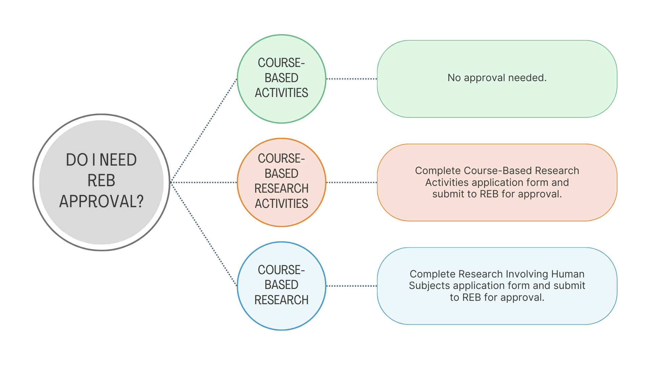
Definitions:
- Course-based activities: Activities conducted by students in a course that are not considered research (e.g., using public information, observation in public spaces where there is no expectation of privacy, creative practice, secondary use of publicly available data, program evaluation, etc.). These activities do not require REB approval normally and would not if being done as part of a course.
- Course-based research activities: Minimal risk research-type activities conducted by students involving human participants for pedagogical purposes (e.g., learning research techniques). To the participant, it is indistinguishable from real research. Examples could include interviews and surveys.
- Course-based research: Research conducted by students with the purpose of doing research (e.g., thesis, capstone, etc.) or as part of an instructor’s research program.
- Minimal risk: Risk is no more than a person encounters in their day-to-day life and does not include anyone in a vulnerable population. Add definition of vulnerability from TCPS

To submit an application for course-based research activities, complete Course-Based Research Activities application form. Send the completed form, any materials described in Question 4 of the application form and proof of TCPS CORE training for instructor (unless already on file with Office of Applied Research and Innovation) to ethics@nwpolytech.ca. Once the semester begins, complete Student Signature Form and forward to Office of Applied Research and Innovation.

