Research Involving Human Subjects Ethics Application

Process for Application:

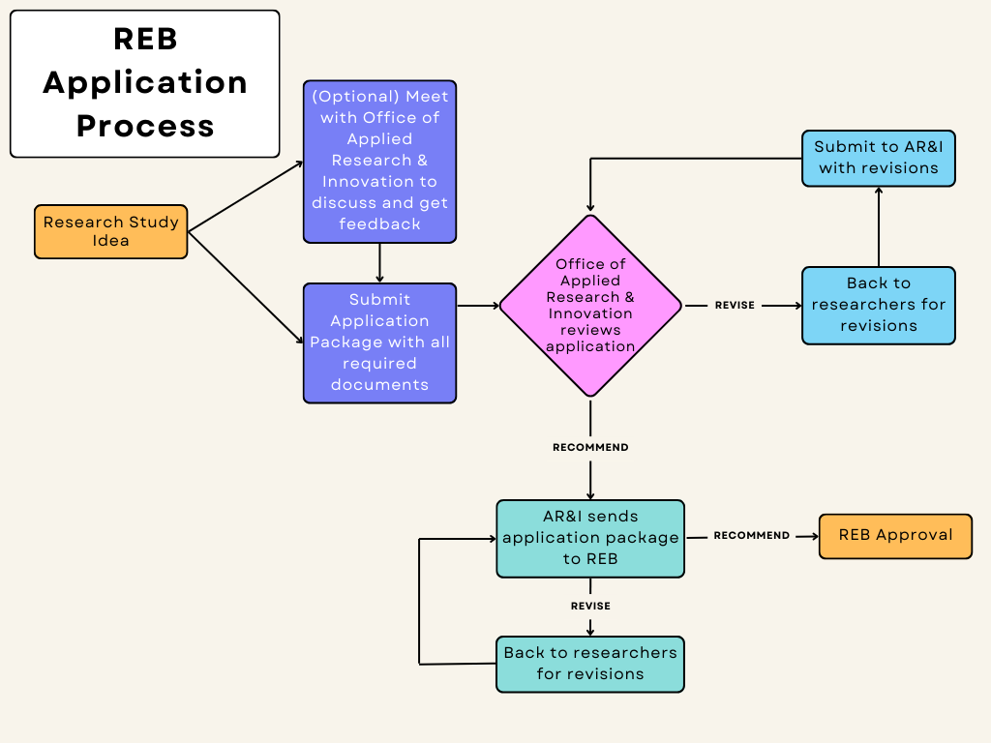

For review, application package must include:
- Completed Research Involving Human Subjects Ethics application form
- Proof of completion of most recent version of TCPS CORE training for all researchers listed on the application (If any members of the research team already have TCPS CORE training documents on file with the Office of Applied Research and Innovation, do not need to resubmit)
- Research protocol using the provided template
- All materials that will be used in the study (e.g., consent forms, recruitment scripts, questionnaires, interview questions, etc.)

Submit all documents to research@nwpolytech.ca for initial review by the Office of Applied Research and Innovation.

Research Involving Human Subjects Ethics Application

- Research team

- Principal investigator (PI)

PI name:

PI department, school/faculty, institution:

PI position:

PI email:

PI phone:

- Research team members

List all current research team members. This includes co-investigators, students, assistants, faculty supervisors, community organizations, and clients.
Name | Email | Role in the Project | Institutional Affiliation

- Project information

- Project title

- Briefly describe this research in non-technical language
    - The research objective(s) and question(s)

    - The importance and contributions of the research

    - Other background information or details that will enable the Research Ethics Board to understand the context of the study when reviewing the application.

- Anticipated duration of the project
    - Anticipated start date for recruitment/data collection

    - Anticipated end date of your research project

- Geographic location(s) of the study

- Project funding

Is this research externally funded?

If yes or pending:
Date of award

Funding source(s)

- Multi-jurisdictional research

Does the proposed research require Research Ethics Board (REB) approval from other ethics board(s)?

If yes, list the other research ethics board(s) from which you or your research team members have sought approval or will seek approval.
Please attach proof of applications, REB approval, or letter of acknowledgement from other research ethics board(s) as appropriate.

- Other approvals and consultations

If additional request(s) for permission/approval are required please list them here (e.g., school district, health authorities, government authority, community group, etc.)
Other approval and consultation | Yes and approval attached | Yes and will provide approval as received | No approval required

- Scholarly review

What type of scholarly review has this research project undergone?
External peer review (e.g., granting agency)
Supervisory committee or supervisor
None
Other
If other, please explain.

- Researcher(s) qualifications

Describe the researcher(s)’ background and the context for this research. Why is this study being proposed? What training, qualifications, or personal experiences do the principal investigator and/or research team members have in relation to the research methods, the nature of the research, and the characteristics of the participants?

Has everyone on the research team completed the most recent TCPS CORE training? If no, please explain. Attach proof of training with application unless already on file with the Office of Applied Research and Innovation.

- Research involving Indigenous peoples of Canada (including First Nations, Inuit, and Métis)

The TCPS highlights the importance of community engagement and respect for community customs, protocols, codes of research practice, and knowledge when conducting research with Indigenous peoples or communities.
Indigenous peoples include First Nation, Inuit, and Métis regardless of where they reside or whether or not their names appear on an official register.

  - Will you be conducting your research on First Nation reserves, Métis settlements, or in communities consisting primarily of Indigenous peoples?

  - Do any of the criteria for participation include membership in an Indigenous community, group of communities, or organization, including urban Indigenous peoples?

  - Does the research seek input from participants regarding an individual’s or a community’s cultural heritage, artifacts, traditional knowledge, or unique characteristics?

  - Will Indigenous identity or membership or citizenship in an Indigenous nation, community, or organization be used as a variable for the purposes of analysis?

  - Will the results of the research refer to Indigenous nations, communities, peoples, knowledge, lived experiences, language, history, or culture?

If you answered yes to any questions H1-H5:

Have you initiated, or do you intend to initiate, an engagement process with the Indigenous nation, organization, community, or communities for this study? If no, please explain.

What specific benefits will the involved nation, organization, community, or communities receive for their participation?

Please explain with whom you have consulted and how you will involve the Indigenous nation, organization, community, or communities in the design, development, and deployment of the study.

Please explain with whom you have consulted and how you will involve the Indigenous nation, organization, community, or communities in the dissemination of results.

What training or learning has been undertaken by the research team to prepare for research with Indigenous nations, organizations, or communities (e.g., working with Knowledge Keepers, Elder, OCAP, traditional Indigenous protocol, other education or experiences)?

- International research

Will this research be conducted in a country other than Canada?

If yes, please list the country(ies) and the processes for research ethics approval in that country.
Country other than Canada where this research will be conducted | Research ethics approval process for each country listed.
Please attach proof of applications and forward approvals upon receiving them.

- Recruitment

  - Participant details
        - Briefly describe the target population(s) for recruitment Ensure that all participant groups are identified. (e.g., group 1 – teachers, group 2 – parents, group 3 – administrators)

        - Why is each population or group of interest?

        - What are the characteristics of the participants for your study (e.g., age, gender, ethnicity, class, position, etc.)?
List all inclusion and exclusion criteria you are using.

        - What is the desired number of participants for each group?

  - Recruitment and process
        - List all source for information used to contact potential participants (e.g., personal contacts, listservs, publicly available information, etc.).

        - List all methods of recruitment.
E.g., in-person, by telephone, letter, snowball sampling, word of mouth, advertisement, etc.

        - If you will be using personal and/or private contact information to contact potential participants (as stated above), have the potential participants given permission for this, or will you use a neutral third party to assist you with recruitment?
Note that this is not a concern when public or business contact information is used.

        - Who will recruit/contact participants?
E.g., researcher, assistant, third party, etc. Clarify for each participant group.

        - List and explain any relationship between the members of the research team (including third party recruiters) and the participant(s).

        - In chronological order (if possible) describe the steps in the recruitment process
Include how you will screen potential participants, where applicable. Consider where the process permission of other bodies may be required.

Please upload all the supporting documents relevant to the recruitment methods identified (e.g., emails, recruitment script, poster, invitation letter, etc.).

  - Power relationship (dual-role and power-over)

Are any of members of the research team in any way in a power relationship, including dual roles, which could influence the voluntariness of a participant’s consent? Could any of the research team members be perceived to be in a power relationship by potential participants?
(e.g., teachers-students, therapists-clients, supervisors-employees, researcher-relative, or researcher-close friend)

If yes, please explain steps to address this.

- Data collection methods

  - Data collection methods
        - Which of the following methods will be used to collect data? Check all that apply.
          - Interview participants
In person
By telephone
Group Interviews or discussions (including focus groups)
Using web-based technology
          - Administering a questionnaire or survey
In person
By telephone
By mail
Using web-based technology
          - Administering a computerized task
Please explain:
          - Observing participants
Please explain:
          - Recording of participants
Audio
Video
Photos or slides
Note taking
Flipcharts
Data collection sheets (attach)
Other
If other, please explain:
          - Using human samples
Hair
Urine
Blood
Saliva
Other
If other, please explain:
          - Using specialized equipment/machines (e.g., ultrasound, sphygmomanometer, EEG, etc.)
Please explain:
          - Other testing equipment not captured under other categories (e.g., artifacts, paintings, drawings, journals, etc.)
Please explain:
          - Collecting materials supplied by, or produced by, the participants
Please explain:
          - Analyzing secondary data or secondary use of data
Please explain:
          - Other
Please explain:

        - Provide a sequential description of the procedures/methods to be used in your research study.

        - Where will the data collection method/procedure(s) take place?

        - For each method, and in total, how much time will be required of participants?

        - Will participants be required to use work hours to complete the study?
Yes
No
If yes, please indicate whether permission is required and how this will be obtained.

  - Data materials checklist
Standardized instrument
Survey
Questionnaire
Interview and/or focus group questions
Observation protocols
Other
Please explain

Please make sure you have attached all the documents relevant to this section.

- Possible benefits, inconveniences, and risks of harm to participants

  - Benefits
Identify any potential or known benefits associated with participation and explain below:
To the participants
To society
To the state of knowledge

  - Inconveniences
Identify and describe any known or potential inconveniences to participants. These may include things such as small disruptions to a routine for data gathering, having to fill out a questionnaire, unremunerated expenses associated with travel, lost work time, physical or emotional discomforts, etc.

  - Level of risk
The TCPS 2 article 6.12 definition of “minimal risk research” is as follows: Research in which the probability and magnitude of possible harms implied by participation in the research is no greater than those encountered by the participant in those aspects of their everyday life that relate to the research.

Based on this definition, do you believe your research qualifies as “minimal risk research”?
Yes
No
If yes, please explain with reference to the risks of the study and the vulnerability of the participants.

  - Estimate of risks harm

Consider the inherent foreseeable risks associated with your research protocol and complete the table below by selecting likelihood for risk of harm.
Potential risks of harm | Likelihood of risk | Explain the risk | What will you do to try to minimize, mitigate, or prevent this risk?
Emotional or psychological discomfort, such as feeling demeaned or embarrassed due to the research
Fatigue or Stress
Social risks, such as stigmatization, loss of status, privacy and/or reputation
Physical risks
Economic risks
Risk of incidental findings
Other risks, explain:

How will you respond if the harm occurs?

If one of your participant groups could be considered vulnerable, please describe any specific considerations you have built into the protocol to address this.
Vulnerable is defined as “a diminished ability to fully safeguard one’s own interests in the context of a specific research project. This may be caused by limited decision-making capacity or limited access to social goods, such as rights, opportunities, and power” (TCPS2, 2022, p. 279).

  - Risk to researcher(s)
Does this research study pose any risks to the researchers, assistants, and data collectors?
Yes
No
If yes, please explain

  - Deception
Will participants be fully informed of everything that will be required of them prior to the start of the researcher session?
Yes
No
If no, please explain your use of deception

- Incentives, reimbursement, and compensation

- Is there any incentive, monetary or otherwise, being offered for participation in the research (e.g., gifts, honorarium, course credits, etc.)?
Yes
No
If yes, please explain

- Is there any reimbursement or compensation for participating in the research (e.g., for transportation, parking, childcare, etc.)?
Yes
No
If yes, please explain

- Explain what will happen to the incentives, reimbursement, or compensation if participants withdraw during data collection or any time thereafter.

- Free and informed consent

  - Are you recruiting any populations with generally lower decisional capacity compared to the average adult (e.g., minors, individuals with intellectual disabilities, etc.)?
Yes
No
If yes, please explain

  - Means of obtaining and documenting consent and/or assent
Check all that apply
Signed consent
Verbal consent
Letter of information for implied consent
Signed or verbal assent from non-competent participants
Consent will not be obtained
Signed consent from the parents/guardians for youth/child participants
Information letters for the parents/guardians of youth/child participants
Other means (please explain)

Please ensure you attach all consent/assent/information documents.

  - Informed consent
Describe the exact steps in chronological order that you will follow in the process of explaining, obtaining, and documenting informed consent.

  - Ongoing consent
Will your research occur over multiple occasions or an extended period of time?
Yes
No
If yes, please explain the multiple occasions and the process of explaining, obtaining, and documenting informed consent.

  - Participant’s right to withdraw
        - Describe what participants will be told about their right to withdraw from the research at any time.

        - What will happen to a person’s data if they withdraw part way through the study or after the data has been collected/submitted?
Participant will be asked if they agree to the use of their data
It will not be used in the analysis and will be destroyed
It is logistically impossible to remove individual participant data
When linked to group data, it will be used in summarized form with no identifying information
Participant will be asked if they can be contacted for follow-up

- Anonymity and confidentiality

- Anonymity
  - Will the participants be anonymous in the data gathering phase of the research?
Yes
No
  - Will the participants be anonymous in the dissemination of the results?
Yes
No
- Confidentiality
  - Are there any limits to protecting the confidentiality of participants?
Yes
No
If yes, please explain

- Use and disposal of data

- Use(s) of data
  - What use(s) will be made of all types of data collected?

  - Will your research data be analyzed, now or in the future, by yourself for purposes other than this research project?
Yes
No
If yes, please provide details of the other purposes.

  - Will your research data be analyzed, now or in the future, by other persons for purposes other than explained in this application?
Yes
No
If yes, please provide details of the other purposes.

- Commercial purposes
  - Do you anticipate that this research will be used for a commercial purpose?
Yes
No
If yes, please provide details of the commercial purpose.

- Maintenance and disposal of data
Describe your plans for protecting data during the project, and for preserving, archiving, or destroying all types of data associated with the research after the research is completed.

  - Means of storing and securing data (e.g., encryption, password-protected computer files, locked cabinet, separation of key codes from raw data, etc.)

  - Location of storing data
Include location of data-storage servers if using web-based technology

  - Duration of data storage
If data will be kept indefinitely, explain why this is necessary and state whether the data will contain identifiers or links to identifiers.

  - Methods of destroying or archiving data
If archiving data, describe measures to secure or protect the data. If the archiving will involve a third party, please provide details.

- Dissemination
How do you anticipate disseminating the research results? (Check all that apply)
Thesis/dissertation
Class presentation
Public or scholarly presentation
Media
Directly to participants and/or groups involved
Published article, chapter, or book
Internet (organization or personal webpage)
Other (please explain)

- Conflict of interest

- Apart from a declared dual-role relationship (section J, 3), are any of the research team members in a perceived, actual, or potential conflict of interest regarding this research project?
Yes
No
If yes, please provide details of this conflict and how it is proposed to manage it.

- List of attached documents

Include required documents as additional attachments with this application.
Descriptive name = the name the document is referred to in this application
File name = name of the file as attached
Type of document = consent form, recruitment document, data collection instrument, TCPS certificate, ethics approval from other organization, etc.
Descriptive name | File name | Type of Document

- Signature

- Principal investigator
By signing the application, I, the PI, whose name appears above will ensure that this project is conducted in accordance with the policies and procedures governing the ethical conduct of research involving human participants at Northwestern Polytechnic. I allow release of my nominative information as required by these policies and procedures. I understand that all information on this form may be subject to verification.
Primary Investigator

Date

- Faculty supervisor (if applicable)
I, the Faculty Supervisor, have read and approved this project and affirm that it has received the appropriate academic approval. I will ensure that the student is aware of the applicable policies and procedures governing the ethical conduct of human subject research at Northwestern Polytechnic and I agree to provide all necessary supervision to the student. I allow release of my nominative information as required by these policies and procedures. I understand that all the information on this form may be subject to verification.
Faculty Supervisor

Date

- Submission
Email completed application and required documents to research@nwpolytech.ca

